**NATIONAL UNIVERSITY OF SCIENCE AND TECHNOLOGY “POLITEHNICA” BUCHAREST**

**Faculty of Engineering in Foreign Languages**

**Computers and information technology - information engineering**

# DIPLOMA PROJECT

**Project coordinator:**

**Conf. Dr. Ing Andrei Vasilateanu**

**Student:**

**Eduard-Andrei Constantin**

**Bucharest**

**2024**

|  |  |  |
| --- | --- | --- |
|  | **NATIONAL UNIVERSITY OF SCIENCE AND TECHNOLOGY “POLITEHNICA” BucHAREST**  **Faculty of Engineering**  **in Foreign Languages**  **Computers and information technology** |  |

# E-commerce Website Template

|  |  |  |
| --- | --- | --- |
| **Project coordinator** |  | **Student:** |
| **Conf. Dr. Ing. Andrei Vasilateanu** |  | **Eduard-Andrei Constantin** |

**Bucharest**

**2024**

|  |  |  |
| --- | --- | --- |
|  | **NATIONAL UNIVERSITY OF SCIENCE AND TECHNOLOGY “POLITEHNICA” BucHAREST**  **Faculty of Engineering  in Foreign Languages**  **Computers and information technology** |  |

**Șablon de Site pentru Comerț Electronic**

|  |  |  |
| --- | --- | --- |
| **Project coordinator** |  | **Student:** |
| **Conf. Dr. Ing. Andrei Vasilateanu** |  | **Eduard-Andrei Constantin** |

**Bucharest**

**2024**

**NATIONAL UNIVERSITY OF SCIENCE AND TECHNOLOGY “POLITEHNICA” BUCHAREST**

**Faculty of Engineering in Foreign Languages**

**Computers and information technology - information engineering**

Approved

Director of department:

Prof. dr. ing. Bujor Pavaloiu

**DIPLOMA PROJECT THEME FOR**:

**Eduard-Andrei Constantin**

1. Theme title:

***E-commerce Website Template***

1. Initial design data:

*Research on current e-commerce website design trends.*

*Analysis of user behavior and preferences.*

*Consideration of mobile and desktop compatibility*

*Integration of essential e-commerce features (shopping cart, product search, user reviews)*

1. Student contribution:

*Conducted a comprehensive market research on effective e-commerce designs.*

*Implemented responsive design for multi-device compatibility.*

*Designed an intuitive user interface emphasizing user experience.*

*Developed a prototype for user testing and feedback collection.*

1. Compulsory graphical material:

*UML diagrams, architecture diagram*

1. The paper is based on the knowledge obtained at the following study courses:

*Systems Engineering, Software Design Techniques, Software Development Methods, Web Application Development*

1. Paper development environment:

*IntelliJ (Java SpringBoot and Angular)*

1. The paper serves as:

*Didactic purposes (bachelor project)*

1. Paper preparation date:

*July 2024*

|  |  |  |
| --- | --- | --- |
| **Project coordinator:** |  | **Student:** |
| **Conf. Dr. Ing. Andrei Vasilateanu** |  | **Eduard-Andrei Constantin** |

# Academic Honesty Statement

I, Eduard-Andrei Constantin, hereby declare that the work with the title “Ecommerce Website Template” to be openly defended in front of the diploma theses examination commission at the Faculty of Engineering in Foreign Languages, National University of Science and Technology "POLITEHNICA" Bucharest, as partial requirement for obtaining the title of Engineer is the result of my own work, based on my work.

The thesis, simulations, experiments and measurements that are presented are made entirely by me under the guidance of the scientific adviser, without the implication of persons that are not cited by name and contribution in the Acknowledgements part.

The thesis has never been presented to a higher education institution or research board in the country or abroad.

All the information used, including the Internet, is obtained from sources that were cited and indicated in the notes and in the bibliography, according to ethical standards. I understand that plagiarism is an offense and is punishable under law.

The results from the simulations, experiments and measurements are genuine.  
I understand that the falsification of data and results constitutes fraud and is punished according to regulations.

Eduard-Andrei Constantin 01.06.2024

**Table of Contents**

1 Introduction 6

1.1 Introduction 6

1.2 Motives 7

1.3 Advantages 7

2 Background 8

2.1 The Rise of E-commerce 8

2.2 The Problem Domain 8

2.3 The Technology Perspective 9

2.4 The Need For A Template 9

3 State of the art 10

3.1 Scientific state of the art 10

3.2 Commercial state of the art 13

3.3 Conclusions 17

4 Requirements analysis 20

4.1 Description of the application 20

4.2 Functional requirements 20

4.3 Non-functional requirements 34

5 Design 35

5.1 Architecture 35

5.2 In-Depth Architecture 37

5.3 Detailed design 38

6 Implementation 41

6.1 Technologies 41

6.2 Registry 43

6.3 Gateway 44

6.4 Product Component 45

6.5 Cart Component 46

6.6 Order Component 47

6.7 Feedback Component 48

7 Validation 49

7.1 Feedback 49

7.2 Improvements 50

7.3 Conclusions 50

8 Conclusions 51

References 52

Annexes 53

Annex 1: List of Acronyms 53

Annex 2: Feedback Survey 53

# Table of Tables

Table 1 Comparison of Key Characteristics Across E-commerce Platforms 14

Table 2 Browsing Products 19

Table 3 Adding Product to Cart 20

Table 4 Checking Out 21

Table 5 Writing a Review or Question 22

Table 6 Account Manangement 23

Table 7 Manage Products 24

Table 8 Manage User Accounts 25

Table 9 Manage Product Categories and Attributes 26

Table 10 Manage Inventory 27

Table 11 Monitor and Respond to Reviews or Questions 28

Table 12 Manage Orders 29

# Table of Figures

Figure 1 - 1 Shopify Dashboard 10

Figure 1 - 2 Magento Dashboard 11

Figure 1 - 3 BigCommerce Dashboard 12

Figure 1 - 4 WooComerce Dashboard 13

Figure 1 - 5 User Use Case Diagram 17

Figure 1 - 6 Admin Use Case Diagram 18

Figure 1 - 5 WooComerce Dashboard 30

Figure 1 - 6 Software Architecture 32

Figure 1 - 7 Basic Request Sequence Diagram 33

Figure 1 - 8 Inter-microservices Communication Sequence Diagram 33

Figure 1 - 9 Gateway Database Diagram 35

Figure 1 – 1- Product Service Database Diagram 36

Figure 1 - 11 Cart Service Database Diagram 37

Figure 1 - 12 Feedback Service Database Diagram 37

Figure 1 - 13 Home Page 39

Figure 1 - 14 Registry Instances Page 40

Figure 1 - 15 Registry Cloud Configuration Page 40

Figure 1 - 16 Gateway Routes Page 41

Figure 1 - 17 Gateway Metrics Page 41

Figure 1 - 18 Product Page 42

Figure 1 - 19 Cart Drawer 43

Figure 1 - 20 Checkout Page 44

Figure 1 - 21 Feedback Page 45

Figure 1 ‑ 22 Feedback Survey 1 50

Figure 1‑ 23 Feedback Survey 2 51

Figure 1 ‑ 24 Feedback Survey 3 51

Figure 1 ‑ 26 Feedback Survey 5 52

Figure 1 ‑ 27 Feedback Survey 6 52

Figure 1 ‑ 28 Feedback Survey 7 53

Figure 1 ‑ 29 Feedback Survey 8 53

Figure 1 ‑ 30 Feedback Survey 53

# 1 Introduction

## 1.1 Introduction

In today's electronic age, shopping has actually become an important element of the international retail framework. As services increasingly change online, the need for effective, straightforward, and scalable ecommerce systems has risen. The structure of such systems is usually built on robust as well as versatile design templates, allowing businesses to tailor and deploy on the internet shops with family member ease. This paper delves into the ins and outs of producing an ecommerce site design template that caters to contemporary services, keeping in mind both scalability as well as functionality.

## 1.2 Motives

The primary motives behind the project are:

* **Simplicity**: To develop a template that minimizes the intricacies related to establishing an online store.
* **Versatility**: To satisfy a broad spectrum of businesses, making certain that the design template can be conveniently adapted to various items, industries, and also customer bases.
* **Scalability**: With e-commerce organizations proliferating, it's crucial that the design template can scale according to the development of business, taking care of enhanced web traffic flawlessly.
* **Affordability**: Guaranteeing that smaller businesses or startups can likewise make use of the project without considerable financial investments.

## 1.3 Advantages

By developing a comprehensive e-commerce website template, numerous advantages arise:

* **Reduced Time-to-Market**: Companies can promptly establish their on the internet presence without the hold-ups of establishing a website from scratch.
* **Cost Efficiency**: Removes the need for customized web advancement, which can often be pricey as well as lengthy.
* **User Experience**: A well-designed template ensures that online consumers have a seamless as well as pleasurable shopping experience, bring about raised sales and also client retention.
* **Flexibility**: Companies can customize and also adapt the template based upon their evolving needs, making sure longevity and significance.

# 2 Background

The shopping sector has metamorphosed into the foundation of retail, showing an unmatched convergence of comfort, array, and customer experience. Allowing buyers to obtain things from the convenience of their residences, e-commerce is not just a trend-- it's the future of buying.

## 2.1 The Rise of E-commerce

From its nascence in the 1990s with systems like eBay and Amazon.com, e-commerce's trajectory has been nothing short of meteoric. This growth can be attributed to numerous intertwined aspects:

* **Digital Revolution**: The last twenty years have actually seen an unmatched increase in internet penetration. With over 4.5 billion net users worldwide, the virtual marketplace's possible audience has actually never been larger. Additionally, smartphones have taken this a notch greater, enabling purchasing on-the-go as well as therefore sustaining ecommerce.
* **Changing Consumer Preferences**: Modern consumers focus on ease. The ability to compare products, read testimonials, as well as make acquisitions with a few clicks, all while lounging in the house, has dramatically transformed shopping characteristics.
* **Globalization**: E-commerce breaks down worldwide obstacles. A supplier in India can easily offer handmade crafts to a purchaser in France. This erasure of conventional geographical constraints opens markets like never previously.

## 2.2 The Problem Domain

Despite the positives, the path to establishing a potent ecommerce existence is filled with obstacles:

* **Technical Barriers**: The technological knowledge needed to set up and also keep an on-line shop is enormous. From making sure internet site security to handling stock, the jobs are diverse.
* **Customization**: The vibrant nature of business world suggests that remedies require to be flexible. A system that helps an apparel brand might not appropriate for a book shop.
* **User Experience**: With the competition being simply a click away, making sure an optimum individual experience is crucial. This requires a rapid internet site, user-friendly user interface, and a smooth checkout process.
* **Scalability**: Predicting development is tricky. An e-commerce platform should thus be designed to take care of both present demands and also future development.

## 2.3 The Technology Perspective

Ecommerce isn't practically selling items on the internet-- it's a melting pot of numerous technological technologies:

* **Deep Learning**: Today's customers expect customized experiences. Deep learning algorithms assess individual habits, from clicks to cart enhancements, to supply customized product recommendations.
* **Graph Databases**: These are critical for mapping the detailed internet of partnerships in e-commerce ecological communities. Whether it's comprehending which items are usually gotten with each other or determining user choices, graph data sources offer indispensable understandings.
* **Recommender Systems**: Beyond just showcasing items, contemporary shopping platforms guide users. Through sophisticated algorithms as well as large datasets, they predict and also present items that a user is most likely to buy.
* **Progressive Web Apps (PWAs)**: Combining the best of sites and mobile apps, PWAs use rapid load times, push notifications, and also offline abilities, raising the buying experience.

## 2.4 The Need for A Template

The numerous opportunities of e-commerce call for a detailed service. While countless systems offer shopping capabilities, there's a palpable gap for a layout that's robust, adjustable, and forward-thinking. Such a design template would certainly encourage businesses, regardless of their dimension, to harness the digital marketplace's potential without grappling with the linked complexities.

**Focus on Reactive Programming**

Incorporating reactive programming, particularly with Java Spring WebFlux, can significantly enhance the template's responsiveness and scalability:

* **Non-Blocking Architecture**: WebFlux's asynchronous and non-blocking nature ensures efficient resource utilization, handling numerous simultaneous requests seamlessly.
* **Event-Driven Model**: Facilitates real-time reactions to user actions, improving the overall user experience.
* **Scalability and Resilience**: With its reactive foundation, WebFlux can scale efficiently and maintain performance even under high load, ensuring a robust e-commerce platform.

By integrating these elements, a well-designed template not only simplifies e-commerce setup but also provides a robust framework to support growth and innovation.

# 3 State of the art

## 3.1 Scientific state of the art

**3.1.1 Articles**

**Soegoto, E. S., Christiani, A., & Oktafiani, D. (2018).** Development of E-Commerce Technology in World of Online Business. *IOP Conference Series: Materials Science and Engineering, 407*. International Conference on Informatics, Engineering, Science and Technology (INCITEST).

In their study from 2018, Soegoto, Christiani, and Oktafiani explore how e-commerce technology has developed in the context of online businesses. Recognizing the evolutionary path and basic benefits of shopping in the current digital commercial sector was the main objective of the research study. By means of a thorough methodology, the scientists illuminated the revolutionary impact of e-commerce technologies, emphasizing in particular the operational effectiveness in sales, repayment agreements, and online reservation systems. The results emphasize how important e-commerce is to supporting online transactional procedures and confirm its importance in the digital corporate setting. The report highlights how faster and more dependable service provided by e-commerce technology improvements has simplified procedures, cut transaction costs, and increased customer satisfaction. Furthermore, covered is how companies can now reach and be more accessible, so serving a worldwide market. The study ends with suggestions for improving e-commerce technologies even more to maintain expansion and competitiveness in the online business sector.

**Bădîrcea, R. M., Manta, A. G., Florea, N. M., Popescu, J., Manta, F. L., & Puiu, S. (2022).** E-Commerce and the Factors Affecting Its Development in the Age of Digital Technology: Empirical Evidence at EU–27 Level. *Sustainability, 14*(1), 101.

Bădîrcea et al. (2022) started comprehensive research aimed at revealing the main causes of the growth of shopping, particularly its short- and long-term effects. Through a strict methodology that included panel regressions, the study examined a number of factors, including customer location, labor market conditions, electronic banking methods, and the distinction between mobile and non-mobile users. Benefiting from a vector mistake adjustment design (VECM) and the fully modified average the very least squares (FMOLS) approach, the study conducted an empirical assessment covering the 27 EU countries between 2011 and 2020. The searches showed that most of these elements directly accelerated the expansion of shopping. Interestingly, though, net acquisitions by non-mobile users and those by out-of-work users were found to be negatively correlated with e-commerce tasks. The implications of these results are further covered in the paper, which implies that although e-commerce growth is generally positive, there are notable differences depending on socioeconomic status and availability to technology. It draws attention to the need of inclusive laws that deal with these differences to guarantee more fair expansion of e-commerce among various groups and geographical areas. The study also suggests that to create a more favourable environment for e-commerce, digital infrastructure and education should be improved.

**Qiu, D., Jing, W., & He, Y. (2019).** Is the Development of E-commerce Spatially Relevant? A Spatial Econometric Analysis. *Proceedings of the 4th International Conference on Crowd Science and Engineering (ICCSE'19)*, 118–126.

The spatial implications of retail expansion are examined by Qiu, Jing, and He (2019), who also examine the widely held belief that shopping innovations are advantageous everywhere. In order to find possible spatial links within the development of e-commerce, the paper focuses on 31 districts in China and uses spatial dimension technologies. Their searches reveal a strange absence of global autocorrelation for China's shopping development, pointing to sporadic and uneven growth throughout different regions. Substantial polarization or diffusion effects concerning e-commerce sales or acquisitions are not revealed by closer local inspection. Still, if one considers businesses involved in e-commerce, a clear polarization and diffusion result emerge. One main finding of the study is the non-significant spatial correlation for e-commerce development between provinces, which is shown by a strong eastern and weak west circulation and suggests possible issues with tier solidification amongst provinces. While some regions have quickly adopted and integrated e-commerce technologies, others lag due to different socio-economic and infrastructural obstacles, the study offers insights into the regional disparities in e-commerce development. The writers suggest focused regional policies to correct these disparities and promote more consistent expansion of e-commerce nationwide. Furthermore, study is advised to determine the fundamental reasons of these spatial differences.

**Ghandour, A., Benwell, G., & Deans, K. R. (2011).** Measuring the Performance of eCommerce Websites – An Owner’s Perspective. *January 2011*.

Ghandour, Benwell, and Deans (2011) go into detail on how to evaluate eCommerce websites and emphasize how crucial performance dimensions are to guiding both functional and tactical goals. Despite extensive study in various contexts over years, the study explains the poor understanding of efficiency metrics in the domain name of eCommerce. With an owner-centric perspective, the authors introduce and empirically validate a website efficiency dimension design. The results characterize performance as a second-order component, with usage, financial gains, and owner satisfaction emerging as the primary components. Both operationalizing and benchmarking web site efficiency are made possible by this model. The report emphasizes the need of having thorough performance metrics that track user engagement and satisfaction levels in addition to traffic and sales. It implies that in order to improve the whole e-commerce experience, website owners should concentrate on a comprehensive strategy for performance measurement that incorporates user input and ongoing improvement techniques. In order to guarantee that e-commerce websites stay competitive and successful, the writers also address the difficulties in putting such metrics into practice and offer ways to get beyond them.

**Tharindu, P. K., & Koggalage, R. (2021).** Usability of E-Commerce Websites: State of the Art and Future Directions. *February 2021*.

Both Tharindu and Koggalage (2021) look at how internet use has become more and more important in e-commerce, especially after the COVID-19 epidemic accelerated the market's growth path. The epidemic's remarkable impact on cross-border shopping has actually made it more crucial than ever to improve conversion rates using cutting-edge techniques. In this sense, web usability has become quite crucial, determining the success and high caliber of interactive platforms. While a wealth of research studies focusses on the functionality of computer system applications, this article focuses on shopping web usability and identifies the advancements reported in scientific publications. The writers also stress how urgently special functionality evaluation techniques designed especially for e-commerce systems are needed. Aspects of usability such as load times, accessibility, navigation, and user interface design are highlighted in the study together with their effects on user behavior and conversion rates. The use of cutting-edge technologies like AI and machine learning to improve user experience, as well as personalization and mobile optimization, are also covered as developing trends in e-commerce usability. In their support of a user-centered design methodology, Tharindu and Koggalage (2021) stress the need of ongoing usability testing and iteration to remain current with evolving user expectations and technology. To create thorough usability frameworks that can be applied to various e-commerce platforms globally and guarantee a smooth and pleasurable shopping experience for consumers everywhere, they also urge more multidisciplinary research.

**3.1.2 Conclusions**

The shopping landscape, as highlighted by Tharindu and also Koggalage (2021), has actually experienced significant upheaval because of the COVID-19 pandemic, accentuating the value of web use. The sudden change and also dependency on on-line platforms highlighted the need for optimum individual experiences to make sure service success as well as customer retention. While there's substantial research study on general internet usability, the unique subtleties of e-commerce systems require specialized examination approaches. The research promotes the pressing requirement for innovative methods tailored for e-commerce, spotlighting locations for future expedition as well as development in the domain name.

## 3.2 Commercial state of the art

**3.2.1 Shopify**

**Overview**: Shopify has become an international leader in the e-commerce platform space, dealing with both beginners as well as skilled business owners. Its Software as a Service (SaaS) technique enables organizations to establish on-line stores without bothering with underlying framework.

* **Advantages**:
  + **User-friendly Interface**: Shopify's user interface is extremely user-friendly, permitting also those without a technical background to set up and also handle their shop easily.
  + **Rich App Store**: Individuals can considerably extend their shop's capacities with plugins and assimilations offered in the Shopify Application Shop.
  + **Secure & Reliable**: Robust security actions such as SSL certification and PCI compliance are common.
* **Disadvantages**:
  + **Limited Customization**: Because Of its SaaS nature, there are constraints on just how much one can customize the core capabilities.
  + **Cost**: While establishing a basic shop is budget-friendly, expenses can quickly climb when adding innovative attributes or scaling up.

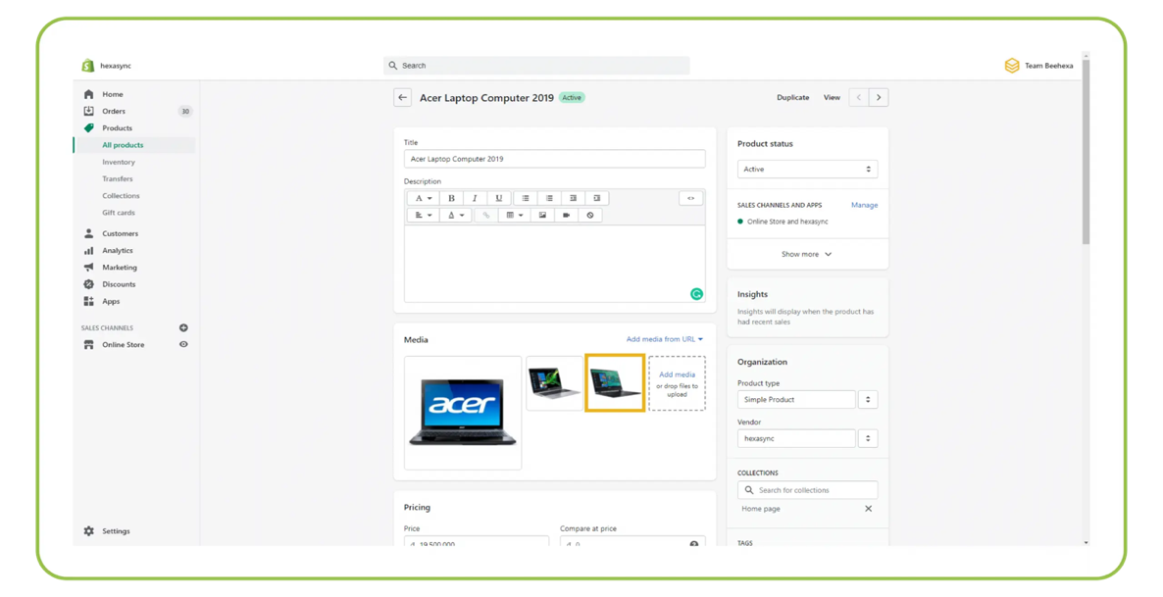

Figure 1 - 1 Shopify Dashboard

**3.2.2 Magento**

**Overview**: Magento, an Adobe company, offers a thorough shopping option. It is particularly favored by tool to massive businesses as a result of its open-source nature and robust attribute set.

* **Advantages**:
  + **Deep Customizability**: Companies can tailor every facet of their store, thanks to Magento's open-source structure.
  + **Scalability**: Designed to take care of substantial product data sources and also traffic.
  + **Vibrant Extension Marketplace**: From SEO tools to payment assimilations, the Magento market has an expansion for practically every requirement.
* **Disadvantages**:
  + **Complexity**: The depth of personalization indicates there's a steeper learning curve, typically requiring dedicated designers.
  + **Performance**: Without correct optimization, Magento sites can experience sluggish lots times.

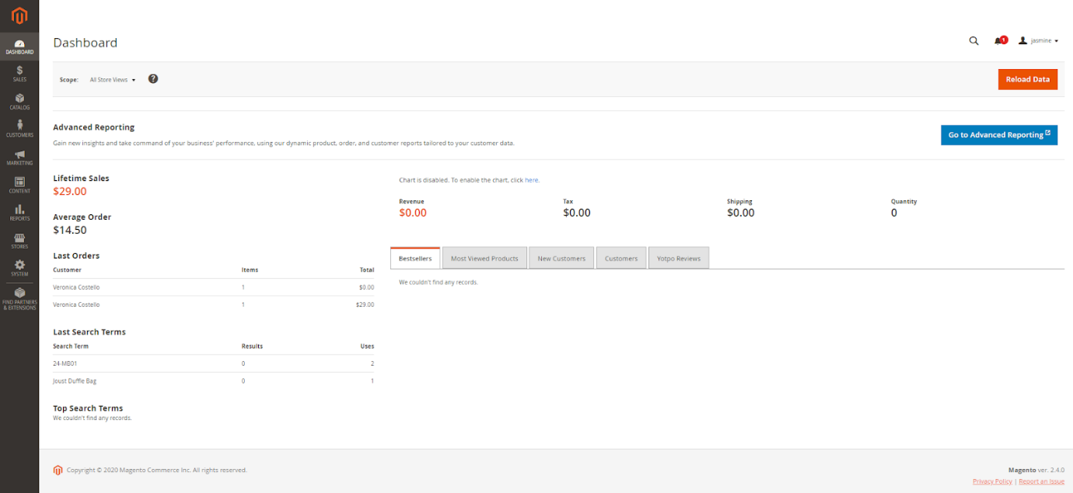

Figure 1 - 2 Magento Dashboard

**3.2.3 BigCommerce**

**Overview**: BigCommerce is an additional strong competitor in the SaaS ecommerce platform room. It boasts a mix of simplicity of use as well as depth of functions, dealing with both small companies and also larger ventures.

* **Advantages**:
  + **Feature-rich Out-of-the-box**: Several innovative attributes are built straight right into the platform, reducing dependence on third-party applications.
  + **SEO Tools**: In-built tools make it less complicated for stores to rank higher on internet search engine.
  + **Transparent Pricing**: Unlike some systems, there are no covert transaction charges.
* **Disadvantages**:
  + **Learning Curve**: While it offers much more integrated attributes than several platforms, it can require time to discover to utilize them all efficiently.
  + **Customization Limitations**: The platform's SaaS nature can occasionally limit deep modification.

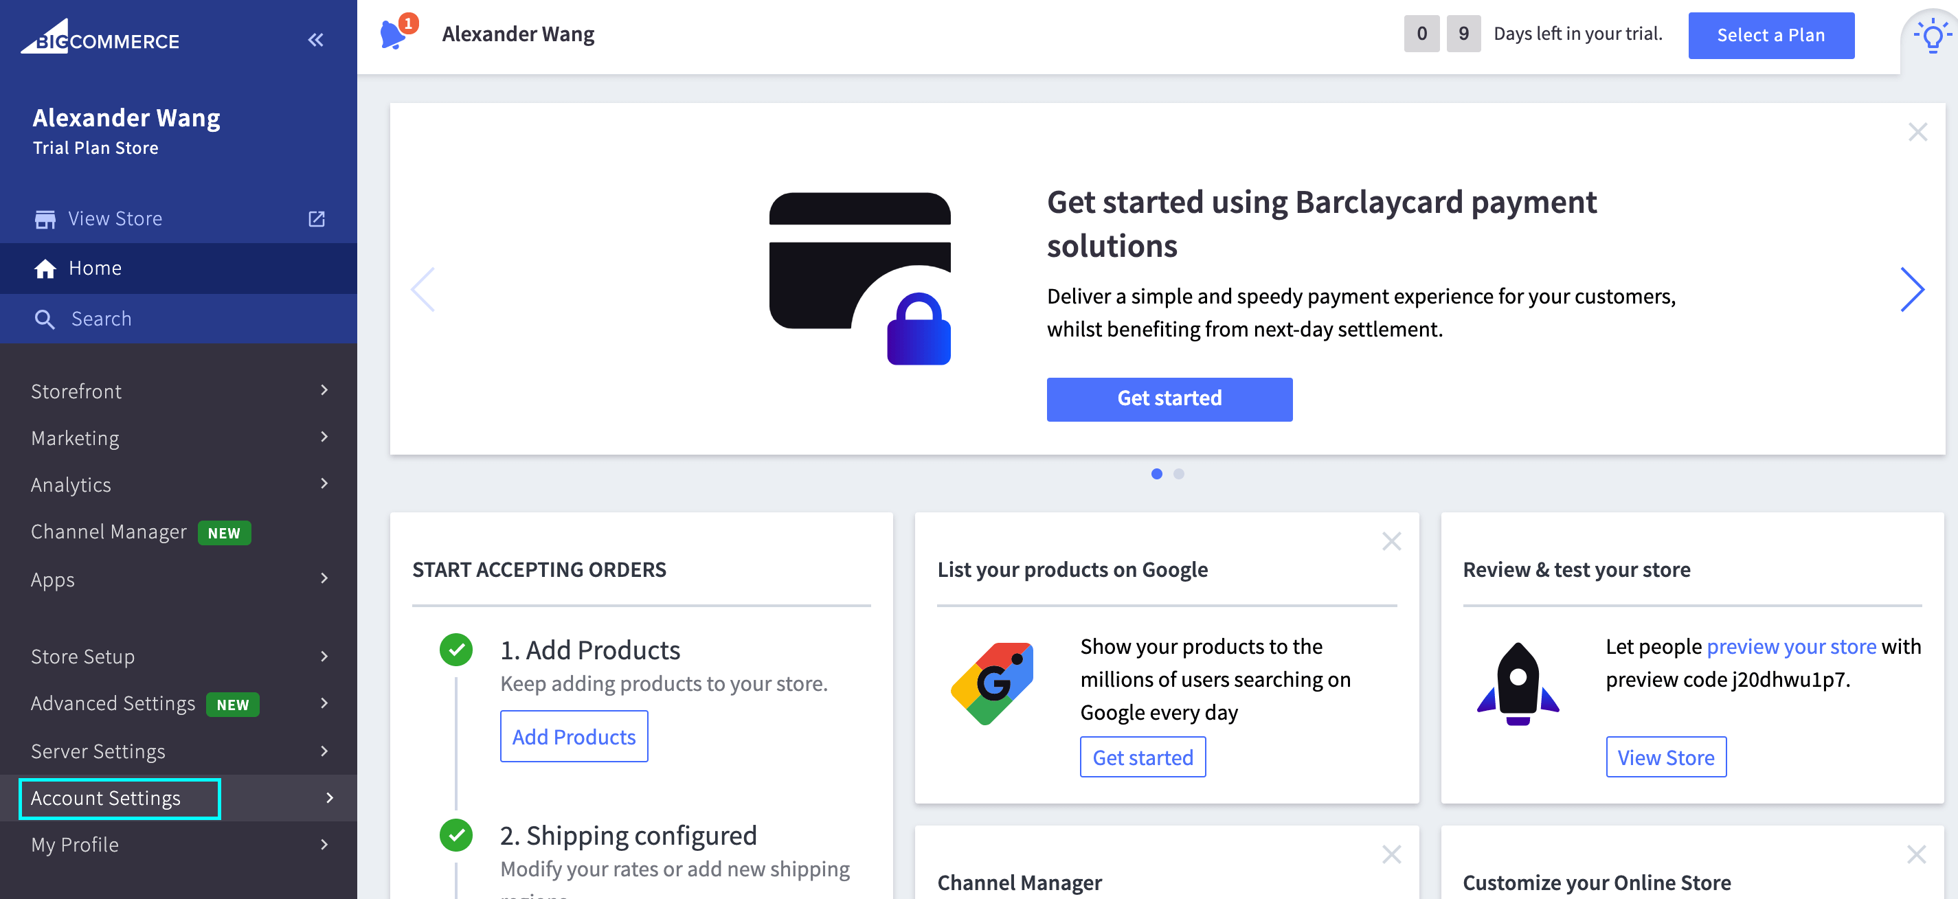

Figure 1 - 3 BigCommerce Dashboard

**3.2.4 WooCommerce**

**Overview**: Based on WordPress, WooCommerce gives a totally free, open-source solution that incorporates flawlessly with the globe's most preferred content administration system.

* **Advantages**:
  + **WordPress Ecosystem**: WooCommerce advantages immensely from the large WordPress environment, offering individuals access to many plugins as well as themes.
  + **Cost-effective**: Being open-source, it's a favored for start-ups as well as local business.
  + **Extensibility**: With plugins, nearly every capability conceivable can be added.
* **Disadvantages**:
  + **Performance**: Out of the box, WooCommerce can have problem with very large item data sources or high traffic.
  + **Requires More Setup**: Unlike SaaS systems, individuals require to handle hosting, security, and updates themselves.

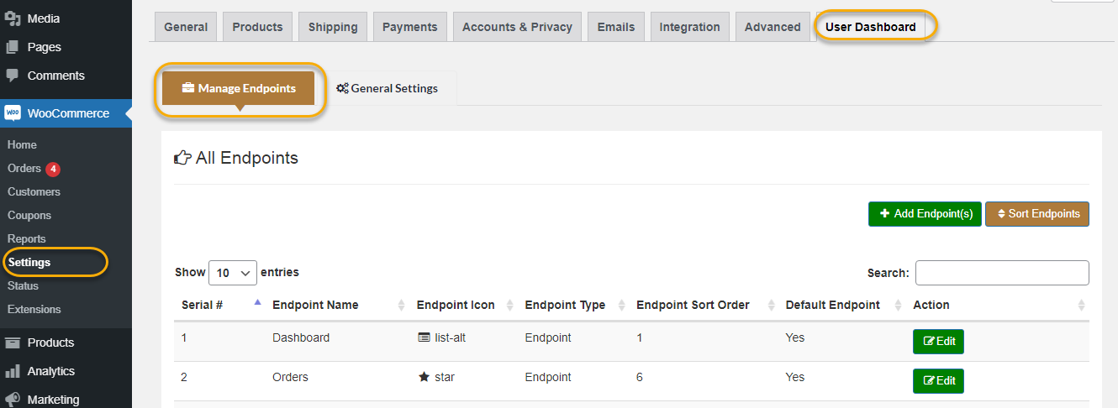

Figure 1 - 4 WooComerce Dashboard

## 3.3 Conclusions

The e-commerce industry has actually seen quick evolution, with multiple systems rising to deal with the diverse demands of services worldwide. Selecting the best platform is vital for services, as it directly affects user experience, scalability, and also general operational efficiency. While each platform has its very own strengths, the ideal selection commonly boils down to the specific needs of business. In the complying with areas, we will certainly offer a comparison table of vital qualities across leading e-commerce platforms to provide a concise introduction for stakeholders.

* Respects the criteria - ✅
* Does not respect the criteria - ❌

Table 1 Comparison of Key Characteristics Across E-commerce Platforms

|  |  |  |  |  |
| --- | --- | --- | --- | --- |
| **Characteristic/Platform** | **Shopify** | **Magento** | **BigCommerce** | **WooCommerce** |
| **Ease of Use** | ✅ | ❌ | ✅ | ❌ |
| **Built-in Features** | ❌ | ✅ | ❌ | ✅ |
| **SEO Tools** | ✅ | ✅ | ✅ | ✅ |
| **Cost-effectiveness** | ❌ | ❌ | ❌ | ✅ |
| **Scalability** | ✅ | ✅ | ✅ | ❌ |
| **Plugin/Extension Market** | ✅ | ✅ | ✅ | ✅ |
| **Performance** | ❌ | ❌ | ❌ | ❌ |

**Analysis**:

* **Ease of Use**: Shopify and also BigCommerce accommodate an extra straightforward experience, particularly for newbies. Magento and WooCommerce, as a result of their integral intricacy, may require a bit extra technological expertise.
* **Customizability**: Open-source platforms like Magento and WooCommerce plainly have the upper hand when it concerns deep customization, providing companies the adaptability they might require.
* **Built-in Features**: The majority of platforms today come packed with necessary attributes to begin an e-commerce service. Nevertheless, the deepness and breadth of these features can vary.
* **SEO Tools**: Modern systems identify the relevance of search engine optimization. As a result, systems like Shopify, Magento, BigCommerce, as well as WooCommerce come with integrated or quickly integrable search engine optimization tools.
* **Cost-effectiveness**: WooCommerce sticks out hereof because of its open-source nature as well as no upfront expenses. Nonetheless, costs can build up with needed extensions as well as hosting.
* **Scalability**: Shopify, Magento, and also BigCommerce are better equipped to handle development and also scale as organizations expand.
* **Plugin/Extension Market**: All platforms supply an abundant selection of plugins or expansions to extend functionality.
* **Performance**: Without added optimization, especially on the web server end, all systems could deal with potential efficiency problems.

Depending on the needs of the company, each e-commerce platform has benefits and drawbacks even if they all provide a variety of functions and capabilities. Newcomers will find Shopify and BigCommerce easy to use, while Magento and WooCommerce offer a great deal of customisation for specific requirements. These platforms vary in their cost, scalability, performance, and built-in features effectiveness, which emphasizes the need of choosing a solution that fits with the resources and objectives of the company.

This study emphasizes how important a tailored e-commerce solution is to improving operational effectiveness and company growth. Our e-commerce solution provides a full, scalable, and affordable substitute for the shortcomings of current platforms.

**Comparative Edge of Our E-commerce Solution**:

* **Ease of Use**: Our platform is user-friendly, allowing even those with limited technical skills to manage their stores easily. Comprehensive documentation and support simplify setup and management for both beginners and advanced users.
* **Customizability**: Each customer starts with a base template that we customize to meet their unique needs. This approach lets businesses implement features and designs that perfectly match their brand. Our team works closely with customers to deliver a tailored solution, ensuring a personalized e-commerce experience.
* **Built-in Features**: Our platform includes essential e-commerce features like product management, inventory tracking, order processing, customer management, and reporting tools. It supports multiple payment gateways, shipping options, and tax configurations, providing a complete out-of-the-box solution.
* **SEO Tools**: Our solution includes advanced SEO tools to improve search engine visibility and rankings. Features like customizable meta tags, clean URLs, and automated XML sitemaps ensure your store is optimized for search engines from the start.
* **Cost-effectiveness**: Our open-source platform avoids the high costs of proprietary systems. While initial setup may have some costs, overall expenses are much lower. Our efficient solution also reduces ongoing maintenance and operational costs.
* **Scalability**: Built on a flexible architecture, our solution scales with your business growth. Microservices enable modular expansion, allowing you to add features and handle more traffic without compromising performance, suitable for small businesses and growing enterprises.
* **Plugin/Extension Market**: Instead of relying on predefined plugins, we offer custom functionalities based on your specific needs. This ensures each customer gets a solution perfectly aligned with their business requirements, offering unmatched flexibility and customization.
* **Performance**: Leveraging Java Reactive and microservices, our platform delivers superior performance with non-blocking operations and efficient resource use. Users enjoy faster load times and smoother shopping experiences, even during peak periods. Our optimized backend ensures high availability and reliability, maintaining customer satisfaction and trust.

# 4 Requirements analysis

## 4.1 Description of the application

## The application concerned is an ecommerce web site template. This ecommerce system aims to deal with various organization requirements, using features varying from item listing and monitoring, buying cart performances, to an user-friendly client testimonial system. Using a reactive Java Spring backend, the system makes sure quick reaction times, effective handling of simultaneous demands, and an overall smoother customer experience.

## 4.2 Functional requirements

**4.2.1 Actor/Agent Identification**:

1. **User**: A visitor of the website who can browse products, add them to cart, and make purchases.
2. **Admin**: The administrator or owner of the website, who can manage product listings, view orders, handle refunds, etc.

**4.2.2 Software Use Case Diagram**

**4.2.2.1 User Use Case Diagram**

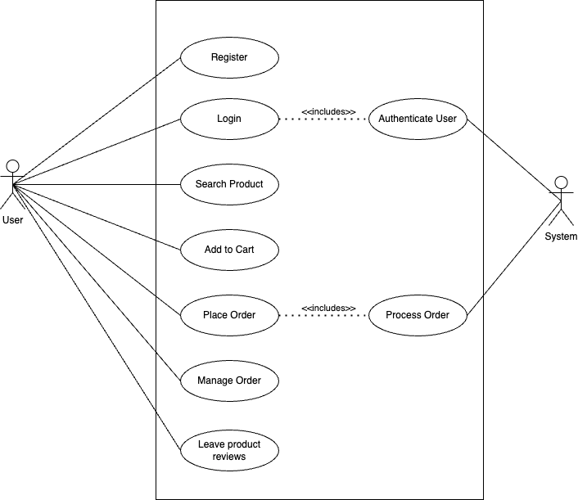

Figure 1 - 5 User Use Case Diagram

This diagram paints a clear photo of the steps a normal user complies with on our website. Initially, they subscribe, creating their own account. As soon as that's done, they can easily log in anytime. After visiting, they can check out the items offered, and also if they locate something they like, they can include it to their cart. Once they decide what they want, they can progress with their purchase. Additionally, they have the alternative to watch on their past and existing orders. If they want to share their experience or ideas concerning a specific product, they can easily leave evaluations for others to read.

**4.2.2.2 Admin Use Case Diagram**

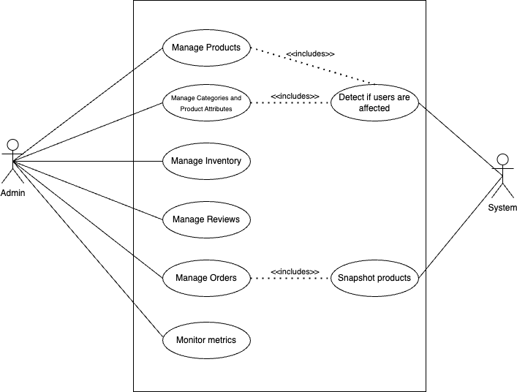

Figure 1 - 6 Admin Use Case Diagram

This diagram is everything about the jobs that the web site admins deal with daily. They are in charge of including new items, making any type of changes to existing ones, as well as arranging them under the right groups. They regularly check to make sure there suffices stock of products so customers don't face any kind of disappointments. Admins can additionally check out the evaluations that individuals leave and also take essential actions if needed. Moreover, they manage the entire order procedure, ensuring every little thing runs smoothly. On top of that, they keep a close watch on web site numbers, guaranteeing every little thing's on track and the web site's wellness is good.

**4.2.3 Software Use Case Description**

**4.2.3.1 User Use Cases Description**

**4.2.3.1.1 UC1 - Browsing Products**

**Description:** Users can browse through a catalog of products on the e-commerce platform.

**Name:** Browsing Products

**Scope:** System

**Actor:** User

**Preconditions:**

* User has access to the internet and is on the platform.
* Products are listed on the platform.

**Postconditions:**

* User views a list of products and can select any product to view more details.

**Main Success Scenario:**

Table 2 Browsing Products

|  |  |
| --- | --- |
| **User** | **System** |
| 1. Navigates to the products page. |  |
|  | 2. Provides list of available products. |
| 3. Scrolls or searches to view more products. |  |
|  | 4. Displays more products or relevant search results as per the user’s input. |
| 5. Clicks on a specific product for details. |  |
|  | 6. Displays detailed information about the selected product. |

**4.2.3.1.2 UC2 – Adding Product to Cart**

**Description:** Users can add a product to their shopping cart for later purchase.

**Name:** Add to Cart

**Scope:** System

**Actor:** User

**Preconditions**:

* User is browsing products.
* User has selected a specific product.

**Postconditions**:

* The product is added to the user's cart.

**Main Success Scenario**:

Table 3 Adding Product to Cart

|  |  |
| --- | --- |
| **User** | **System** |
| 1. Browses the products and selects a specific product. |  |
|  | 2. Displays detailed information about the selected product along with an “Add To Cart” option. |
| 3. Clicks on the “Add to Cart” button |  |
|  | 4. Adds the product to the user’s cart and opens the drawer cart. |
| 5. Chooses to close the drawer cart and continue shopping or checkout. |  |
|  | 6. Continues to display the updated cart icon indicating the number of items in the cart. |

**4.2.3.1.3 UC3 – Checking Out**

**Description:** Users finalize their product selections and proceed to purchase.

**Name:** Checkout

**Scope:** System

**Actor:** User

**Preconditions:**

* User has added one or more products to their cart.
* User is ready to finalize the purchase.

**Postconditions:**

* User completes the purchase and receives a confirmation.

**Main Success Scenario:**

Table 4 Checking Out

|  |  |
| --- | --- |
| **User** | **System** |
| 1. Clicks on the shopping cart icon. | 2. Displays current user profile details, addresses, and password management options. |
|  | 2. Displays all the items in the cart along with their details, quantities and total price. |
| 3. Clicks on the “Checkout” button |  |
|  | 4. Prompts the user to input shipping and payment details, or to confirm if they already stored. |
| 5. Fills in or confirms the necessary details and finishes the order. |  |
|  | 6. Processes the order and provides a confirmation message. |

**4.2.3.1.4 UC4 – Writing a Review or Question**

**Description:** Users can write a review or a question for the product.

**Name:** Review Product

**Scope:** System

**Actor:** User

**Postconditions:**

* User's review/question is posted and visible to other users.
* Admin can now answer or reply to question/review.
* If the user has bought the product, the review is marked as verified.

**Main Success Scenario:**

Table 5 Writing a Review or Question

|  |  |
| --- | --- |
| **User** | **System** |
| 1. Navigates to a specific product’s details page. |  |
|  | 2. Displays product information along with existing reviews and questions. |
| 3. Clicks on the “Write a Review” or “Ask a Question” button. |  |
|  | 4. Presents a form for the user to enter their review or question. |
| 5. Enters the details of the review along with images or asks a question and submits the form. |  |
|  | 6. Saves the review/question and displays it under the product’s details. |
| 7. If the user has bought the product. |  |
|  | 8. Marks the review as “Verified Buyer” |

**4.2.3.1.5 UC5 – Account Management**

**Description:** Users can update their profile, manage addresses, and change passwords.

**Name:** Manage Account

**Scope:** System

**Actor:** User

**Preconditions:**

* User has logged into their account.

**Postconditions:**

* User has updated the necessary details on their profile.

**Main Success Scenario:**

1. Navigates to the "Account Management" or "Profile" section.

Table 6 Account Manangement

|  |  |
| --- | --- |
| **User** | **System** |
| 1. Navigates to the "Account Management" or "Profile" section. |  |
|  | 2. Displays current user profile details, addresses, and password management options. |
| 3. Chooses to update personal profile details. |  |
|  | 4. Provides an editable form populated with current profile details |
| 5. Modifies personal information and clicks the "Save" button. |  |
|  | 6. Updates and saves the modified details in the database, then confirms the changes to the user. |

**4.2.3.2 Admin Use Cases Description**

**4.2.3.2.1 UC1 – Manage Products**

**Description**: Admin can add, edit, or remove products from the platform.

**Name**: Manage Products

**Scope**: System

**Actor**: Admin

**Preconditions**:

* Admin is logged in.
* Admin has access rights to manage products.

**Postconditions**:

* Product listings on the platform are updated based on admin actions.

**Main Success Scenario**:

Table 7 Manage Products

|  |  |
| --- | --- |
| **Admin** | **System** |
| 1. Navigates to the “Store Management” -> “Products” section. |  |
|  | 2. Displays a list of current products with management options |
| 3. Selects “Add Product” and enters details |  |
|  | 4. Validates and adds the new product, confirming its addition. |
| 5. Chooses to edit an existing product |  |
|  | 6. Provides an editable form with current details, and updates upon submission |

**4.2.3.2.2 UC2 – Manage User Accounts**

**Description**: Admin can view, edit, or remove user accounts.

**Name**: Manage User Accounts

**Scope**: System

**Actor**: Admin

**Preconditions**:

* Admin is logged in.
* Admin has access rights to manage user accounts.

**Postconditions**:

* User accounts are updated or maintained based on admin actions.

**Main Success Scenario**:

Table 8 Manage User Accounts

|  |  |
| --- | --- |
| **Admin** | **System** |
| 1. Navigates to “User Management” |  |
|  | 2. Displays a list of user accounts with management options. |
| 3. Selects a user account to edit. |  |
|  | 4. Provides editable details of the user. |
| 5. Saves changes or removes the account. |  |
|  | 6. Updates user account data or removes it from the system. |

**4.2.3.2.3 UC3 – Manage Product Categories and Attributes**

**Description**: Admin can organize products by adding or editing categories and attributes, ensuring easy navigation for users.

**Name**: Category and Attributes Management

**Scope**: System

**Actor**: Admin

**Preconditions**:

* Admin is logged in.
* There are products listed on the platform.

**Postconditions**:

* Products are categorized and attributed accordingly.

**Main Success Scenario**: (Admin system interactions sequence)

Table 9 Manage Product Categories and Attributes

|  |  |
| --- | --- |
| **Admin** | **System** |
| 1. Navigates to “Store Management” -> “Products” and selects “Category” or “Attributes”. |  |
|  | 2. Displays current categories or attributes for the products. |
| 3. Adds/edits a category or attribute. |  |
|  | 4. Updates the category/attribute list with the new changes along all the products that have that category/attribute. |
| 5. Assigns products to specific categories or attributes. |  |
|  | 6. Products are now listed with the specific category/attributes. |

**4.2.3.2.4 UC4 – Manage Inventory**

**Description**: Admin can track the inventory of products and receive alerts when stock is low or depleted.

**Name**: Inventory Management

**Scope**: System

**Actor**: Admin

**Preconditions**:

* Admin is logged in.
* Products are listed with their stock numbers.

**Postconditions**:

* Inventory is updated and maintained.

**Main Success Scenario**:

Table 10 Manage Inventory

|  |  |
| --- | --- |
| **Admin** | **System** |
| 1. Navigates to “Store Management” -> “Products”. |  |
|  | 2. Displays products along with their stock numbers. |
| 3. Clicks the edit icon to edit a product. |  |
|  | 4. Provides the editable product details. |
| 5. Edits the stock number. |  |
|  | 6. Adjusts inventory count based on admin input. |

**4.2.3.2.5 UC5 – Monitor and Respond to Reviews or Questions**

**Description**: Admin can monitor product reviews and ratings. They can also respond to any concerns raised in the reviews.

**Name**: Review Monitoring and Response

**Scope**: System

**Actor**: Admin

**Preconditions**:

* Admin is logged in.
* Users have submitted product reviews or questions.

**Postconditions**:

* Admin has overseen and responded to reviews or questions.

**Main Success Scenario**:

Table 11 Monitor and Respond to Reviews or Questions

|  |  |
| --- | --- |
| **Admin** | **System** |
| 1. Navigates to “Store Management” -> “Reviews and Questions” |  |
|  | 2. Displays a list of recent product reviews and questions. |
| 3. Selects a review or question. |  |
|  | 4. Displays review/question details. |
| 5. Responds to or resolves user’s concern. |  |
|  | 6. Updates the review/question with admin’s response. |

**4.2.3.2.6 UC6 – Manage Orders**

**Description**: The admin can view, process, and manage all orders placed by customers on the platform. This includes overseeing order status, adjusting order details if necessary, and handling order-related queries.

**Name**: Order Management

**Scope**: System

**Actor**: Admin

**Preconditions**:

* Admin is logged in.
* There are orders placed by users.

**Postconditions**:

* Orders are successfully managed, ensuring timely delivery and customer satisfaction.

**Main Success Scenario**:

Table 12 Manage Orders

|  |  |
| --- | --- |
| **Admin** | **System** |
| 1. Navigates to “Store Management” -> “Orders” |  |
|  | 2. Displays a list of recent orders placed by users. |
| 3. Selects an order to view details. |  |
|  | 4. Shows comprehensive order details. |
| 5. Modifies order details or status if necessary. |  |
|  | 6. Updates the selected order with the changes made. |

**4.2.4 Activity Diagram**

This diagram is a snapshot of how users and administrators interact on the site:

* **Users:** They can browse products, make purchases, and leave feedback. Their journey revolves around finding and acquiring what they want and voicing their opinions about their experiences.
* **Admins:** They have a bigger role. Admins make sure the products are up-to-date, handle special promotions, and oversee the feedback given by users to ensure quality control.

In short, this image paints a clear picture of the different actions both users and administrators undertake on the website, ensuring smooth operations and a pleasant experience for everyone.

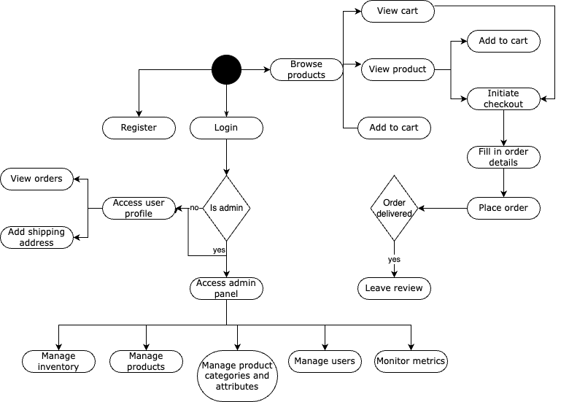

Figure 1 - 5 WooComerce Dashboard

## 4.3 Non-functional requirements

1. **Performance**:
   * The system must respond to customer demands within 2 seconds under typical load.
   * The check out procedure ought to complete within 5 secs to stop cart abandonment.
2. **Scalability**:
   * The system needs to sustain up to 10,000 concurrent customers.
   * It should be created to quickly scale horizontally, to allow the easy flow of resources during high-demand times.
3. **Availability**:
   * The system ought to have an uptime of 99.9%, ensuring individuals can access it at almost whenever.
   * Any type of maintenance that calls for downtime must be arranged throughout off-peak hours and communicated ahead of time to the customers.
4. **Security**:
   * All individual data must be encrypted both en route and at rest.
   * Regular safety and security audits must be performed to determine and also remedy vulnerabilities.
5. **Usability**:
   * The user interface should be instinctive as well as need minimal assistance for a new user.
   * The system should support responsive design, ensuring usability on both mobile and desktop platforms.
6. **Maintainability**:
   * The system's code should adhere to industry best practices, ensuring easy updates and bug fixes.
   * Comprehensive documentation should be maintained, detailing system architecture, data flow, and other essential aspects.

# 5 Design

## 5.1 Architecture

**5.1.1 Software Architecture**

The architecture diagram showcases an integrated system catering to both mobile and desktop platforms. Both platforms interface directly with the frontend layer. This frontend subsequently connects to a centralized gateway. The gateway interfaces with a registry, which further establishes a secure connection with a cloud-based configuration vault, ensuring the security and centralized management of configurations. Additionally, the gateway plays a pivotal role by acting as a conduit to multiple microservices, efficiently load balancing the traffic amongst them. Each of these microservices is independent and operates with its own dedicated database, ensuring data isolation and modularity in the system's design.

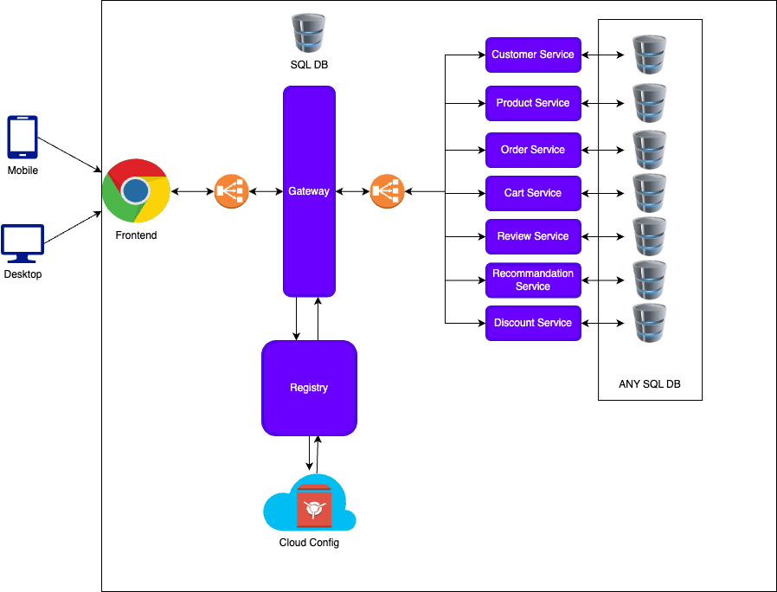

Figure 1 - 6 Software Architecture

**5.1.2 Basic Request Sequence Diagram**

This diagram illustrates the standard flow of communication for a user request. The user initiates a request which travels through the frontend interface, progressing to the gateway. At the gateway, the user's credentials are authenticated. Upon successful authentication, the request is forwarded to the respective microservice that interacts with the database to process the user's request.

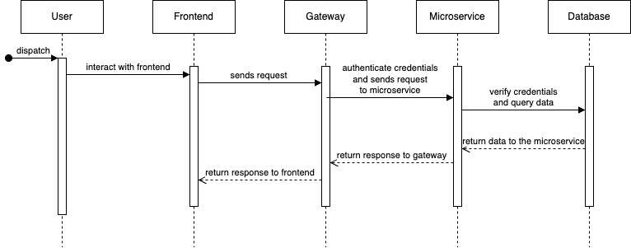

Figure 1 - 7 Basic Request Sequence Diagram

**5.1.3 Inter-microservice Communication Sequence Diagram**

This sequence portrays the intricate communication between two microservices. A user's request navigates through the frontend and reaches the gateway for authentication. Once authenticated, the request is directed to 'microservice 1'. This microservice then relays a JWT (JSON Web Token) to 'microservice 2'. Upon successful verification of the credentials by 'microservice 2', the interaction with the database occurs to fulfill the user's request.

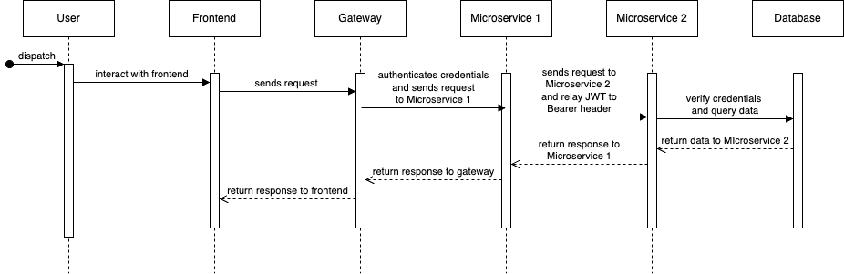

Figure 1 - 8 Inter-microservices Communication Sequence Diagram

## 5.2 In-Depth Architecture

**5.2.1 Microservices Architecture**

Opting for a microservices-based approach means that each functional module of the platform, be it product management, cart handling, or order processing, exists as an independent service.

**5.2.2 JHipster Registry and Gateway**

Leveraging the JHipster Registry and Gateway ensures an organized and streamlined communication pathway for services. The registry facilitates service discovery while the gateway consolidates external communications, offering a unified access point for clients.

**5.2.3 Reactive Paradigm with Spring WebFlux**

Spring WebFlux, with its reactive programming model, ensures the system is both responsive and resilient, especially when handling a vast number of simultaneous client requests or dealing with service latencies.

**5.2.4 Data Management and Cloud Storage**

With PostgreSQL handling relational data storage and MinIO overseeing image assets, the platform ensures robust data management. Furthermore, using cloud storage solutions for image assets means that the system can effectively handle large volumes of data without being bogged down, ensuring faster access times and reduced latency.

**5.2.5 Containerization and Cloud Deployment**

Docker containers offer both isolation and portability. This means services can be developed, tested, and deployed in a consistent environment. More importantly, containerization dovetails perfectly with cloud deployment, allowing the platform to harness the scalability and flexibility that cloud infrastructures provide.

**5.2.6 Frontend and User Experience**

The choice of Angular, complemented by Bootstrap, ensures that users are met with a smooth, interactive, and responsive interface. This guarantees a pleasant shopping experience on the platform.

## 

## 5.3 Detailed design

**5.3.1 Registry**

**Objective:** Ensure efficient service discovery in a distributed system.

**5.3.2 Gateway**

**Objective:** Route requests efficiently and provide a unified API interface and keeps user details.

**Database**

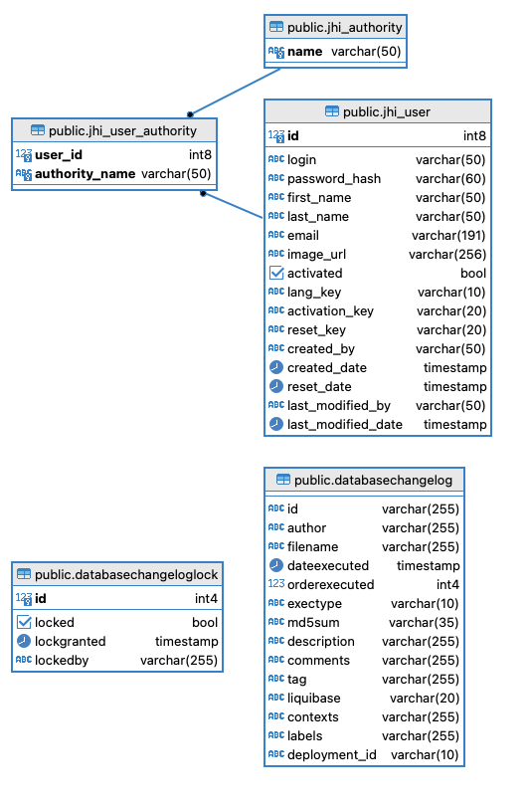

Figure 1 - 9 Gateway Database Diagram

**5.3.3 Product Service**

**Objective:** Manage the catalog of products, ensuring accurate, up-to-date information is available to users.

**Database**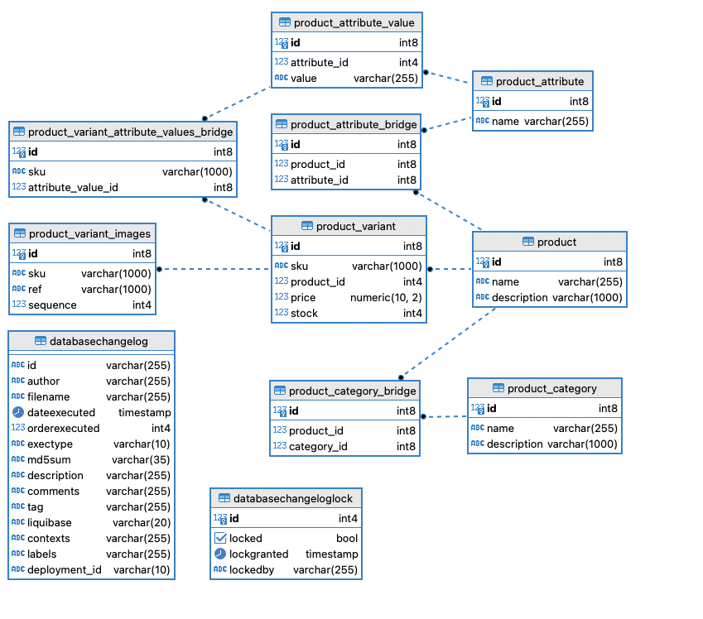

Figure 1 – 1- Product Service Database Diagram

**5.3.4 Order Service**

**Objective:** Efficiently handle the entire order lifecycle, from placement to delivery, ensuring a smooth user experience.

**5.3.5 Cart Service**

**Objective:** Facilitate seamless shopping experiences for users.

**Database**

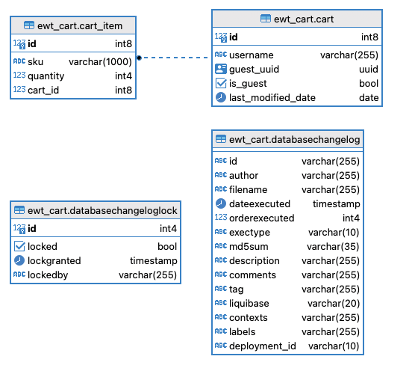

Figure 1 - 11 Cart Service Database Diagram

**5.3.6 Feedback Service**

**Objective:** Provide a platform for users to share feedback, ask questions, and review products, enhancing trust and community engagement.

**Database**

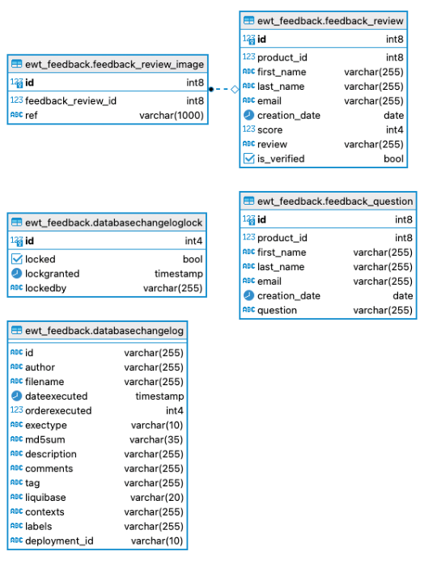

Figure 1 - 12 Feedback Service Database Diagram

# 6 Implementation

## 6.1 Technologies

**Backend:**

* **Spring Boot**: At the core of our backend is Spring Boot, an open-source Java-based framework used to create stand-alone, production-grade Spring-based applications. It simplifies the process of building production-ready applications by providing essential defaults.
* **Spring WebFlux**: To cater to the increasing demand for reactive web applications, we've adopted Spring WebFlux. It's a reactive programming framework, allowing our application to handle a large number of concurrent connections with minimal thread usage.
* **Reactive Spring**: Ensures non-blocking data access, especially vital for scalable microservices, making the system responsive even under heavy loads.

**Frontend:**

* **Angular**: Angular serves as the foundation of our web UI. Its component-based structure, combined with two-way data binding, ensures a dynamic and real-time user interface.
* **Bootstrap**: Ensures a consistent and responsive design across devices. Its vast collection of ready-to-use components accelerates the UI development process.

**Database:**

* **PostgreSQL**: Our choice for a relational database system. Known for its extensibility, SQL compliance, and ability to manage large volumes of data.
* **Liquibase**: An open-source database-independent library for tracking, managing, and applying database schema changes. It aids in maintaining a consistent database state across different environments.

**Infrastructure & Deployment:**

* **JHipster Registry**: Acts as a runtime config server and service discovery agent. It's pivotal in managing, monitoring, and scaling microservices in the system.
* **JHipster Gateway**: Operates as an entry point to our microservices ecosystem, handling routing, load balancing, and security.
* **Docker**: Containerization is key in modern software delivery. With Docker, we ensure consistent environments from development to production, making deployments smooth and predictable.
* **MinIO**: High-performance object storage. It's our choice for storing images, providing scalability, security, and performance.

**Security:**

* **JWT (JSON Web Tokens)**: An open standard that defines a compact and self-contained way for securely transmitting information between parties as a JSON object. We use JWT for user authentication and authorization, ensuring data safety and integrity.

With this stack of technologies, we've laid the foundation for an application that is scalable, secure, and maintainable. Each technology was chosen not just for its individual prowess but how well it meshes with others, creating a seamless and robust ecosystem.

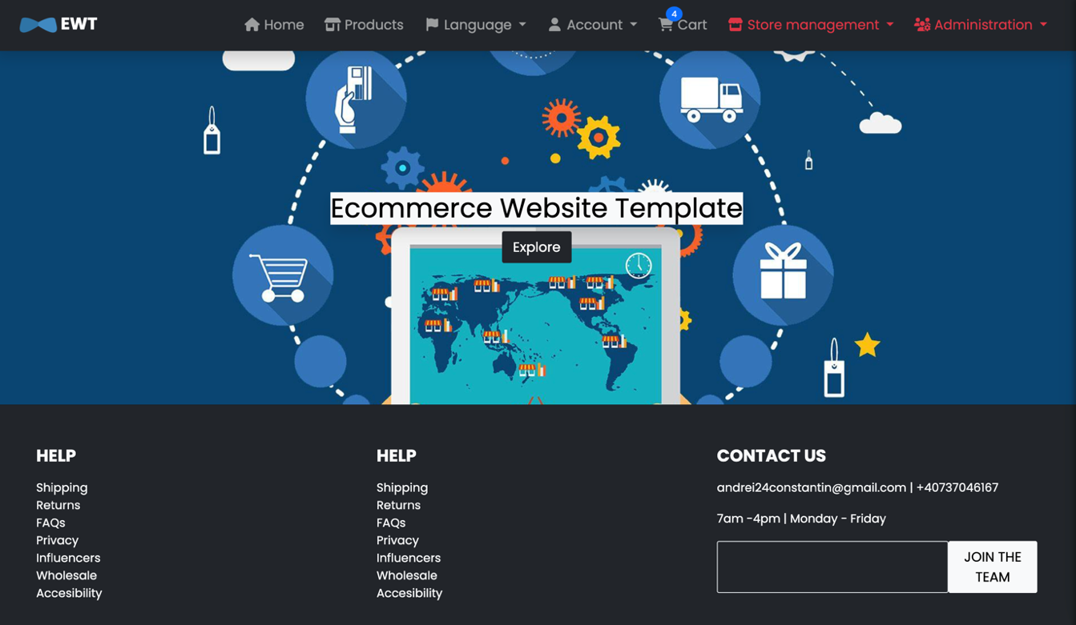

Figure 1 - 13 Home Page

## 6.2 Registry

The Registry is a pivotal component of our microservices architecture. Operating as a system's nerve center, it manages the service discovery mechanism:

* **Service Registration:** Whenever a new service instance, be it Product Service or Cart Service, is spun up, it automatically registers itself with the Registry. This registration process includes specifying the service's network location, the offered APIs, and other metadata.
* **Service Discovery:** Other services or clients can query the Registry to discover the network locations of service instances.
* **Load Balancing:** The Registry plays a passive role in load balancing. When a client or service queries for a particular service, the Registry provides the address of all instances, allowing the client to implement its load-balancing mechanism.

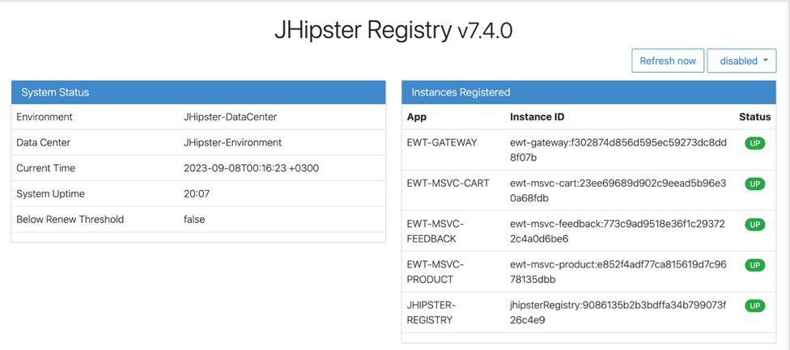

Figure 1 - 14 Registry Instances Page

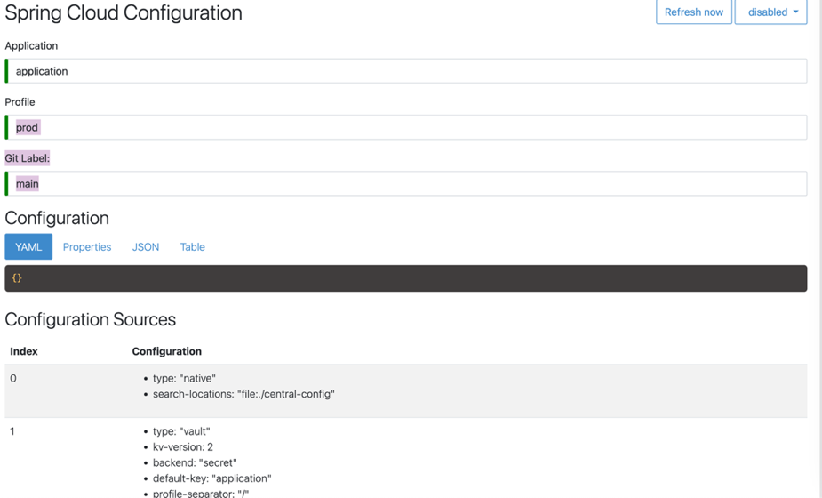

Figure 1 - 15 Registry Cloud Configuration Page

## 6.3 Gateway

The Gateway is more than just an entry point; it encapsulates several cross-cutting concerns:

* **Request Routing:** Based on the incoming request, the Gateway determines which service or services should handle the request.
* **Security:** The Gateway handles authentication and can also manage authorization by inspecting tokens or other credentials and ensuring that the caller has the correct permissions.
* **Rate Limiting:** Ensures that no service is overwhelmed with too many requests, thereby providing a self-throttling mechanism to our microservices environment.

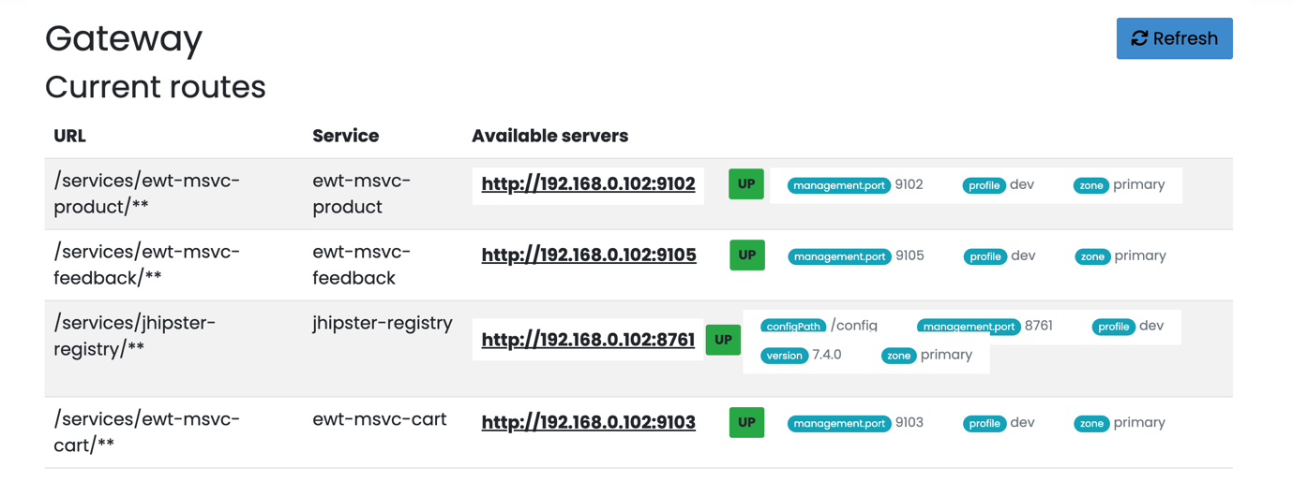

Figure 1 - 16 Gateway Routes Page

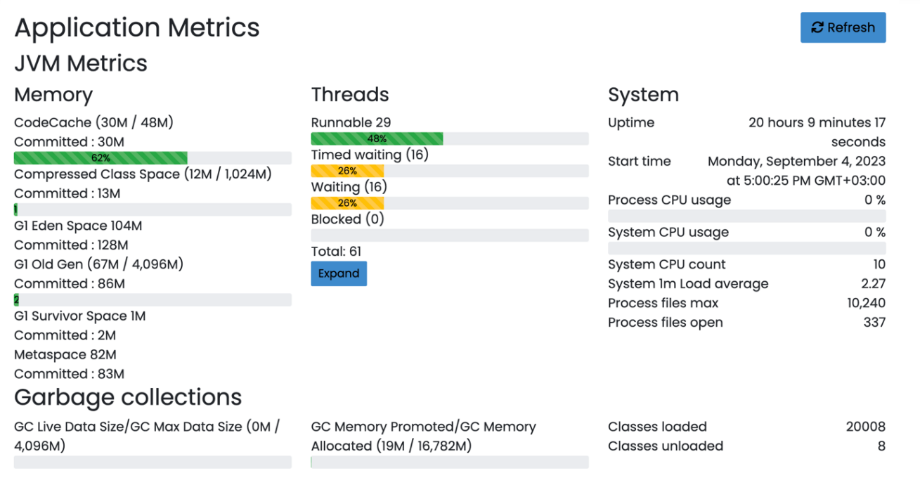

Figure 1 - 17 Gateway Metrics Page

## 6.4 Product Component

**Key Features**:

* **Product Categorization:** Products can be categorized, allowing for easier browsing and searching by users.
* **Image Management:** As products often have multiple images showcasing different angles or features, this service handles the storage, retrieval, and deletion of product images.
* **Product Variants and Attributes:** Products might have different variants (e.g., size, color). The service efficiently handles these variants, ensuring users can select their preferred choice.
* **Product Search**: Allow users to efficiently search, filter, and sort through the product catalog.
* **Scalability:** Given the high volume of product interactions, the service is designed to handle a large number of concurrent requests without degradation in performance.

**Admin Panel Features for Product Service**:

* **Product Management**: Add, edit, or remove products and their details.
* **Inventory Oversight**: Get detailed insights on stock levels, sales rates, and restocking needs.
* **Product Analytics**: Understand which products are the bestsellers and which might need more promotion.

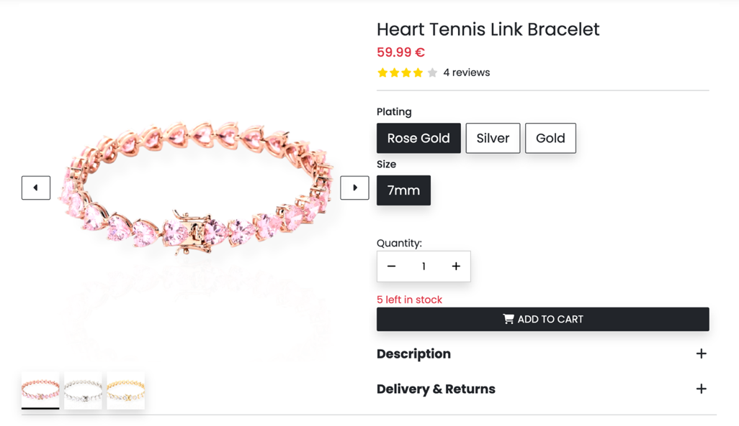

Figure 1 - 18 Product Page

## 6.5 Cart Component

**Key Features:**

* **Cart Operations:** Allows users to add, remove, or modify product quantities in their cart. Ensures these operations are speedy and reliable.
* **Pricing Calculations:** Dynamically recalculates cart's total value as users modify cart contents. Also factors in promotions, discounts, or loyalty points.
* **Temporary Storage:** Carts can be ephemeral for non-logged-in users. Upon login, the service merges any temporary cart with the logged-in user's existing cart.
* **Integration:** Interacts closely with the Product Service, notably for checking product availability or fetching current prices.

**Admin Panel Features for Cart Service:**

* **Cart Monitoring:** Track active carts, identifying potential for abandoned carts.
* **Cart Analytics:** Understand user shopping behavior and average cart values.

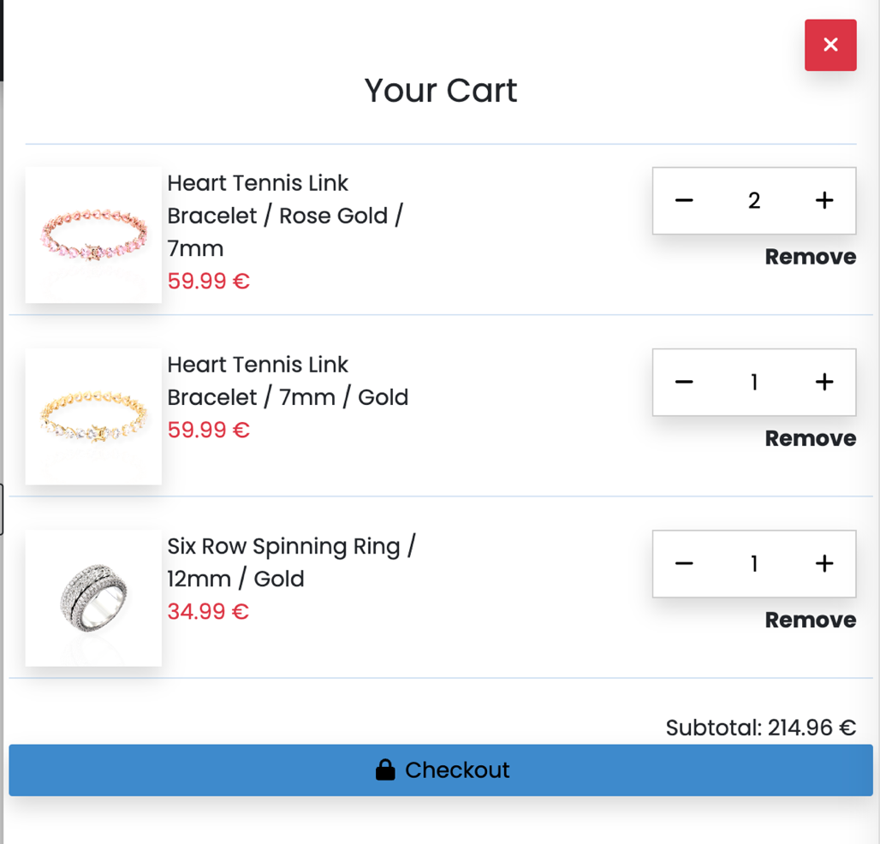

Figure 1 - 19 Cart Drawer

## 6.6 Order Component

**Key Features:**

* **Order Placement:** Users can finalize their cart, initiating the order process.
* **Order Tracking:** Provide real-time updates to users on the status of their orders.
* **Payment Integration:** Securely process payments, supporting multiple payment methods.
* **Shipping Integration:** Coordinate with shipping providers to ensure timely and accurate deliveries.
* **Order History:** Users can revisit their past orders, aiding in repurchases or warranty claims.

**Admin Panel Features for Order Service:**

* **Order Management:** Oversee all active and past orders, with capabilities to modify or cancel if necessary.
* **Payment Oversight:** Monitor payment gateways and handle any payment disputes or refunds.
* **Shipping Management:** Coordinate with shipping providers and handle any issues related to delivery.
* **Customer Support:** Assist customers with any inquiries or issues related to their orders.

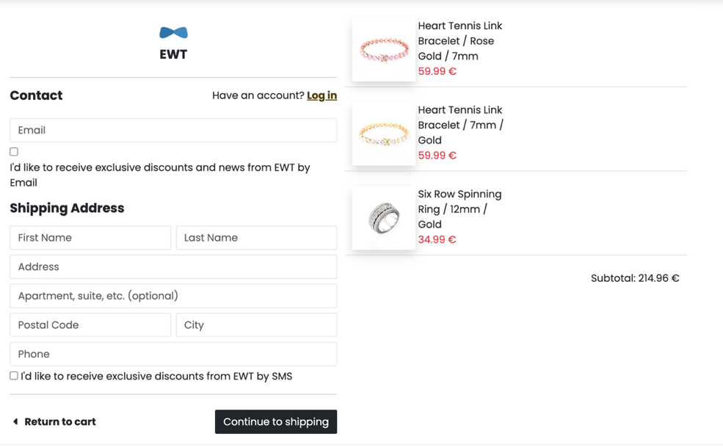

Figure 1 - 20 Checkout Page

## 6.7 Feedback Component

**Key Features**:

* **Reviews**: Allow users to leave product-specific reviews, showcasing both positive and negative experiences.
* **Questions & Answers**: Users can pose questions about specific products, and either the community or the company can provide answers.
* **Review Verification**: By interacting with the Order Service, the system verifies if the reviewer has purchased the product. Verified reviews are then marked accordingly to increase trust.
* **Aggregation**: Calculate and display average product ratings based on user reviews, helping potential buyers make informed decisions.

**Admin Panel Features for Feedback Service**:

* **Review Moderation**: Monitor, flag, or remove inappropriate reviews.
* **Verified Reviews**: Highlight and manage reviews marked as 'Verified Purchase'.
* **Answer Oversight**: Oversee the question and answer section, ensuring accurate and helpful information.
* **Feedback Analytics**: Understand the general sentiment towards products and identify areas of improvement.

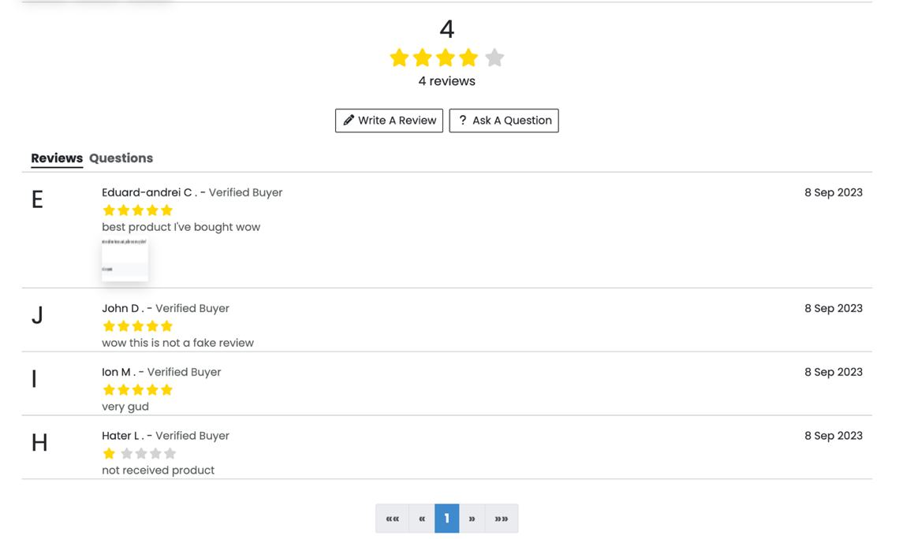

Figure 1 - 21 Feedback Page

# 7 Validation

## 7.1 Feedback

This chapter shares the feedback gathered through the Google Form survey, targeted at understanding customer experiences, choices, and suggestions for to the ecommerce website template.

The survey had 22 participants, whom I chose from a network of personal and professional contacts with backgrounds in business, marketing, and information technology. They shared their insights into their online shopping habits, as well as their honest opinions about the platform's capabilities and features. The Google Form had 9 inquiries, with 1 being an optional text field:

**Q1:** How often do you shop online?

Leading option with 36.4%, the "Monthly" option.

**Q2:** How would you rate the overall design and layout of our platform?

54.5% rated it as "Good".

**Q3:** Did you find the product search functionality effective and intuitive?

59.1% responded with "Yes, very much".

**Q4:** How satisfied are you with the product information provided?

"Very Satisfied" gathered 68.2% of the votes.

**Q5:** Did our platform's navigation feel smooth and user-friendly?

81.8% found it "Extremely user-friendly".

**Q6:** Which feature of our platform did you find most helpful?

"Admin panel" led the way with 40.9%.

**Q7:** Did you face any challenges during the checkout process?

Thankfully, 95.5% faced no issues.

**Q8:** How likely are you to recommend our platform to friends or family?

“Likely” and “Very likely” both have the lead with 45.5%

**Q9:** What improvements or additional features would you like to see on our platform?

This was a textual question and gathered only one response.

## 7.2 Improvements

The feedback suggests our e-commerce platform is on the right track, with many users pleased with its features. Yet, in any successful online platform, there's always room for growth and refinement. Here are some insights from the feedback that could enhance our user experience even more:

1. **Enhanced Product Information**: While 68.2% of respondents were 'Very Satisfied' with the product information provided, there's still room for improvement. High-resolution images, interactive 360-degree views, video demonstrations, or augmented reality try-ons for certain products could be explored to enrich the user experience. This would make the product descriptions more interactive and might even cater to the remaining 31.8% of users who seek more comprehensive information.
2. **Advanced Admin Panel Features**: The admin panel, being the most helpful feature for 40.9% of the respondents, indicates a potential opportunity. Enhancing the admin panel with better analytics, user behavior heatmaps, or predictive inventory management can make the platform even more robust and user-friendly.
3. **Recommendation Engine Refinement**: The fact that the "Likely" and "Very likely" categories in recommending the platform both stood at 45.5% implies that users see the platform's potential. Optimizing the recommendation algorithms could lead to more personalized product suggestions, enhancing the shopping experience.
4. **Streamlined Checkout Process**: Even though an overwhelming 95.5% faced no issues during checkout, it’s worth analyzing if the process can be made even faster or more intuitive. Integrating more payment gateways, introducing one-click checkout, or even offering localized payment options could be beneficial.

## 7.3 Conclusions

The feedback from our survey shows that people really like our online shopping site. Most users are happy with how the site looks, how they can search for products, and how easy it is to get around. Plus, a lot of them would tell their friends to use our site, which means they trust us.

But we can't just be happy with this and stop working. In the online shopping world, things change fast, and we have to keep up. Even if only one person gives us an idea or feedback, we should listen. It's always good to know what people think, whether a lot of them tell us or just a few.

Looking ahead, we need to keep doing what we do well and fix any problems. I want to give the users the best experience and keep being the top choice when they shop online

# 8 Conclusions

# In today's tech world, it's super important to make things that are new and user-friendly. This report talks about how I made and improved my online shopping site. Looking back, there are some key things I noticed.

# Firstly, what people say about the site is really important. Like I wrote in the earlier chapters, feedback from users was a big help. The things I learned from people who used the site helped me make it better. I tried to make sure that the site was easy to use and would keep being useful in the long run.

# Also, making the site was sometimes tricky. I used the latest tools and tried my best to make sure the site works well and looks good. I learned a lot from the challenges I faced, which taught me how important it is to keep improving and adapting.

# People gave some ideas for making the site even better. The site works well now, but there's always more to do. I'll keep trying to make it better and fit what users want.

# All in all, making this online shopping site was hard but rewarding. Every step had its ups and downs. This report shows how much effort I put in and how committed I was. I hope my site becomes a great example of being flexible and creative as technology keeps changing.

# Looking ahead, there's a lot that can be done with this strong foundation. The future has so much in store, and I'm excited to see what more my site can do.

# References

[1] Usability.gov (2023) 'User-Centered Design Basics', Usability.gov. Available at: https://www.usability.gov/what-and-why/user-centered-design.html

[2] Econsultancy (2022) 'Ecommerce Best Practice Guide', Perkin, N. Available at:

https://econsultancy.com/reports/ecommerce-best-practice-guide/

[3] Harold Kerzner (2017). Project management: a systems approach to planning, scheduling, and controlling (pp 493-495)

[4] Elham Ghadri Soufi, Saeed Soltani Mohammadi, Hadi Mokhtari (2018). Model of a Work Breakdown Structure (WBS) Framework and AOA Diagram for Efficient Project Management of Lead a Zinc Skarn Exploration with Exploratory Data (pp 89-100)

[5] Daniel,F., Hardy A. Forbes (2022) 'How To Make A Small Business Website’,. Available at: https://www.forbes.com/advisor/in/business/software/how-to-make-a-website-for-your-business/

[6] HubSpot (2023) 'How to Design a Website: A Step-by-Step Guide from a Web Designer', HubSpot Blog. Available at: https://knowledge.hubspot.com/get-started/build-your-website

[7] Dragoni, N. et al. (2017). Microservices: Yesterday, Today, and Tomorrow. In: Mazzara, M., Meyer, B. (eds) Present and Ulterior Software Engineering (pp195-216]

[8] Siau, K., Lee, L. (2004) Are use case and class diagrams complementary in requirements analysis? An experimental study on use case and class diagrams in UML (pp 229-237)

[9] Medium (2023) ‘Let’s talk about Scalable Design’, Medium. Available at: https://medium.com/pixelmatters/scalable-design-7adbaafa5086

[10] W3Schools (2023) 'Responsive Web Design - Templates', W3Schools. Available at: https://www.w3schools.com/w3css/w3css_templates.asp

[11] A List Apart (2023) 'Responsive Web Design', A List Apart. Available at: https://alistapart.com/article/responsive-web-design/

[12] Baymard Institute (2022) 'E-Commerce Checkout Usability', Baymard Institute. Available at: https://baymard.com/checkout-usability

# Annexes

## Annex 1: List of Acronyms

* Blob: Binary Large Object
* API: Application Programming Interface
* ARCS: Attention, Relevance, Confidence, Satisfaction (model of motivational design)
* IT: Information Technology
* HR: Human Resources
* UC: Use Case
* MVC: Model-View-Controller
* CSV: Comma-Separated Values
* PNG: Portable Network Graphics

## Annex 2: Feedback Survey

## Questions

Figure 1 ‑ 22 Feedback Survey 1

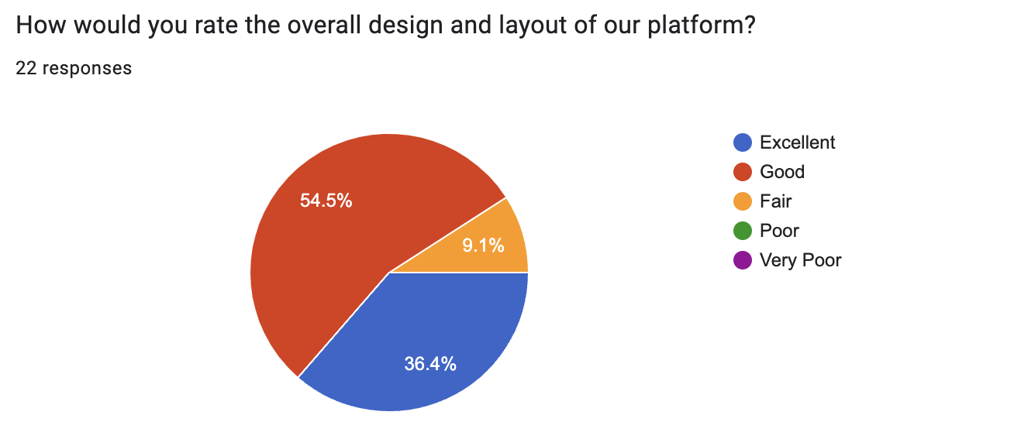

Figure 1‑ 23 Feedback Survey 2

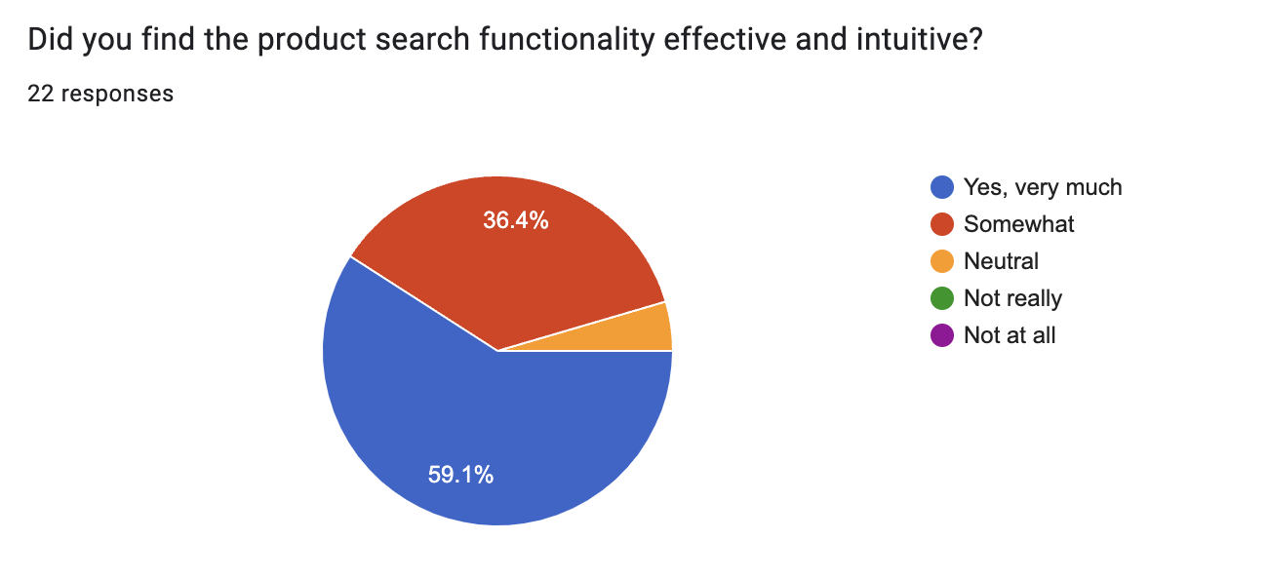

Figure 1 ‑ 24 Feedback Survey 3

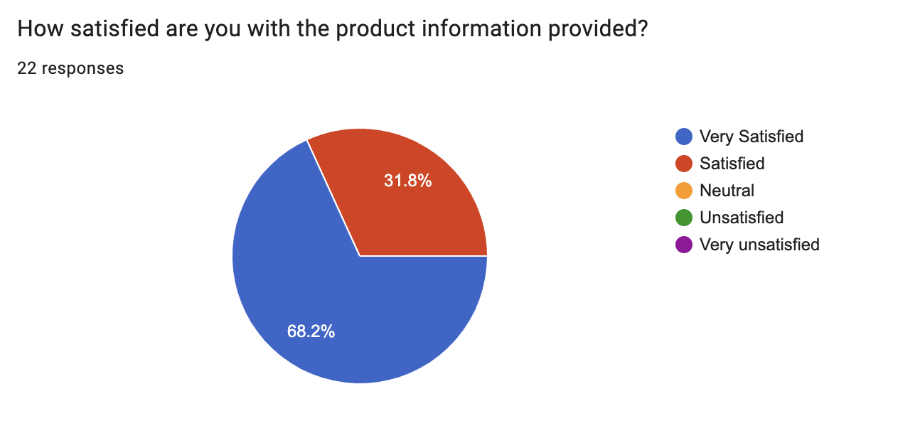 Figure 1 ‑ 25 Feedback Survey 4

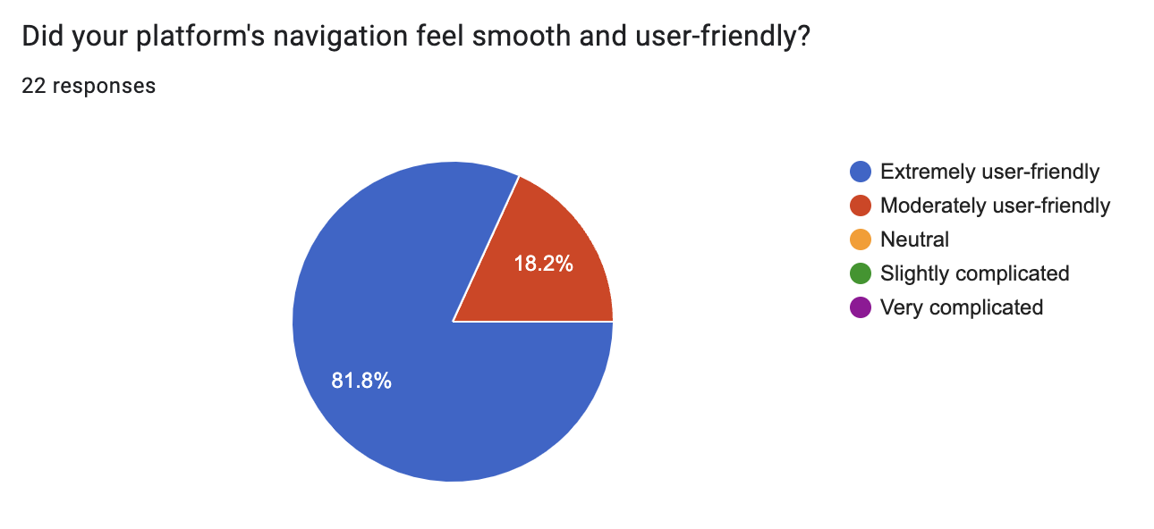

Figure 1 ‑ 26 Feedback Survey 5

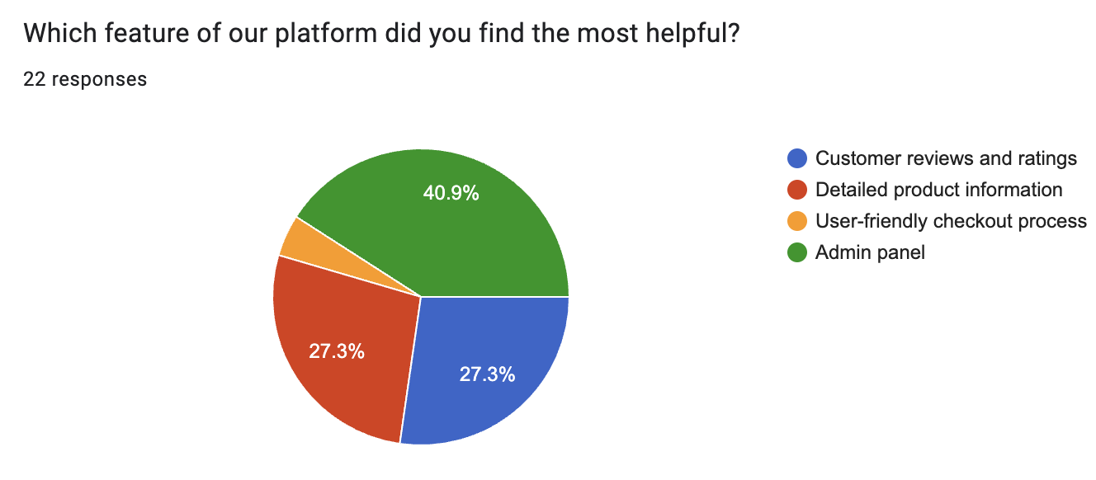

Figure 1 ‑ 27 Feedback Survey 6

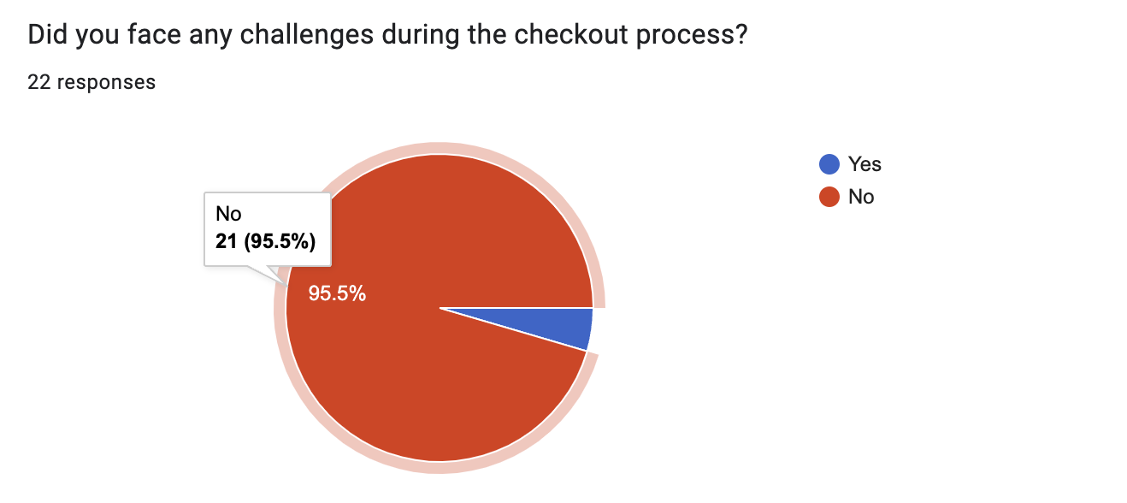

Figure 1 ‑ 28 Feedback Survey 7

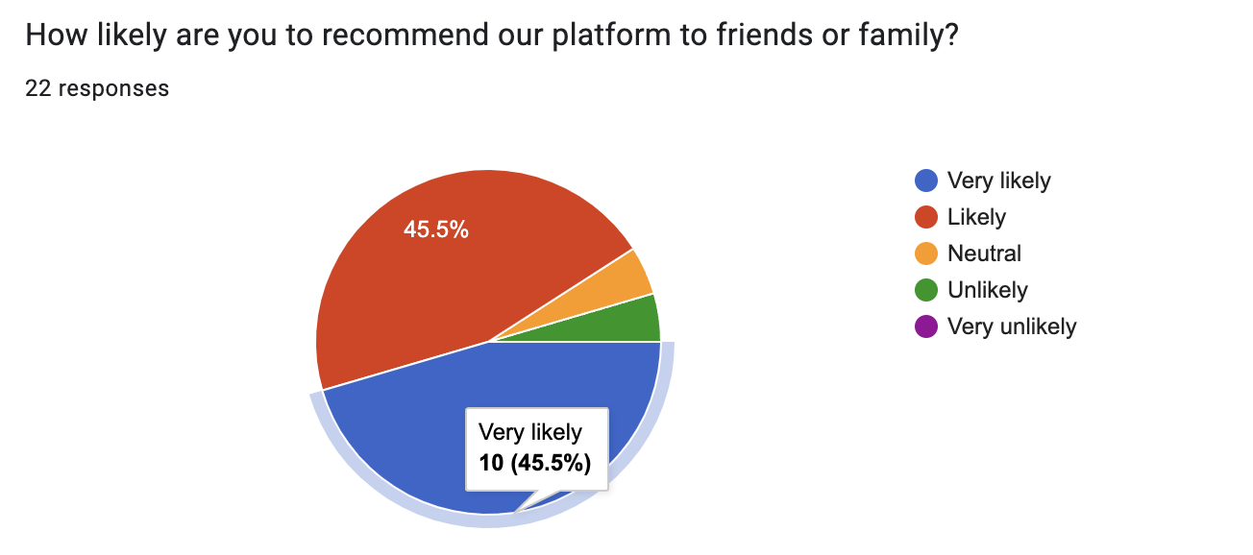

Figure 1 ‑ 29 Feedback Survey 8



Figure 1 ‑ 30 Feedback Survey